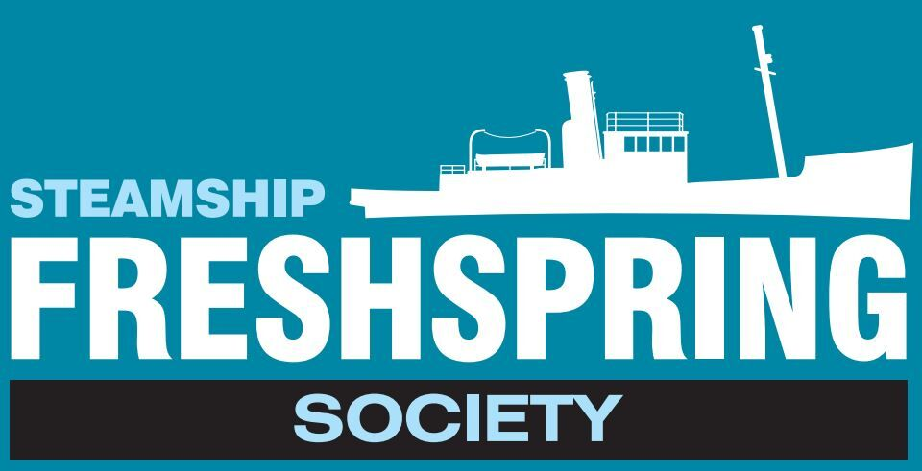
Photography Consent Form

The Steamship Freshpspring Society would like to take photos of your pupils/students/youth group participating in Society projects for advocacy purposes. These images may appear in printed publications, on DVD, our website, social media or on a promotional CD.

The Society’s Policy for using Photographs and Videos
- Schools must give written permission for the use of any photographs or video
- Children’s names will not accompany photographs unless they are prize winners and we have their permission
- Photographs will be kept for five years and then destroyed and not used again

Please tick
- May we use images from this project in our printed advocacy (such as newsletters)?
- May we use images from this project on our website?
- May we use images from this project on our social media pages?
- May we record images from this project on promotional CDs/DVDs?

I consent to the Steamship Freshspring Society taking and using any photographs or film produced from this project
- I confirm that I have obtained the permission of the adult/parent/carer/person with custody of any children or young person who appears in the photograph/film
- I am aware that the school and those at the school appearing in the photograph/film have no rights of ownership, copyright or other interest in the photograph/film produced.
- I understand and agree to the Society using any photograph/film produced for the purposes agreed, as indicated above

Name of Group Leader/Teacher………………………………………………………………………...

Signature…………………………………………………………………… Date ……………………………………



